- The S&P Global surveys for August reported a stronger pace of private sector activity growth. But sectoral fortunes contrasted, with a higher upturn in the services sector, while manufacturing output softened. Though the composite PMI has been slightly higher than in H1 2024, we expect GDP growth will be a bit slower in Q3 than the high rates experienced in recent quarters.
- Survey data suggested that price and wage pressures continue to cool. But with the Monetary Policy Committee having previously sent a strong message that a September rate cut was unlikely, this week's data is unlikely to cause the committee to alter this plan.
A relatively quiet week for data releases has largely supported our prior views on the economy. Namely that output is rising at a solid rate and indicators of inflation persistence are moderating, albeit not at a pace that will cause the Bank of England's Monetary Policy Committee to deviate from the gradual approach to rate cuts that they advocated at August's meeting.
August's final S&P Global survey reported an increase in the composite PMI to 53.8, from 52.8 in July. The rise was entirely driven by stronger activity in the services sector. Here, the details were encouraging, with the balances for new orders and business sentiment remaining high, albeit a touch softer than July's elevated outturns. Meanwhile, employment growth improved further, suggesting firms think the recent upturn in services activity will have some durability. In contrast, a modest slowing in manufacturing output weighed on August's composite PMI.
The average composite PMI over the first two months of Q3 was slightly higher than that seen in H1 2024. But the composite PMI has been a poor leading indicator of GDP growth rates in recent years, with volatility in sectors not covered by the S&P Global survey playing a big role (Chart 1). So, despite the positives from August's survey, we remain sceptical that q/q GDP growth in Q3 will replicate the above-trend rates experienced in the first two quarters of this year.
Chart 1: The composite PMI suggests activity growth is likely to remain solid in Q3
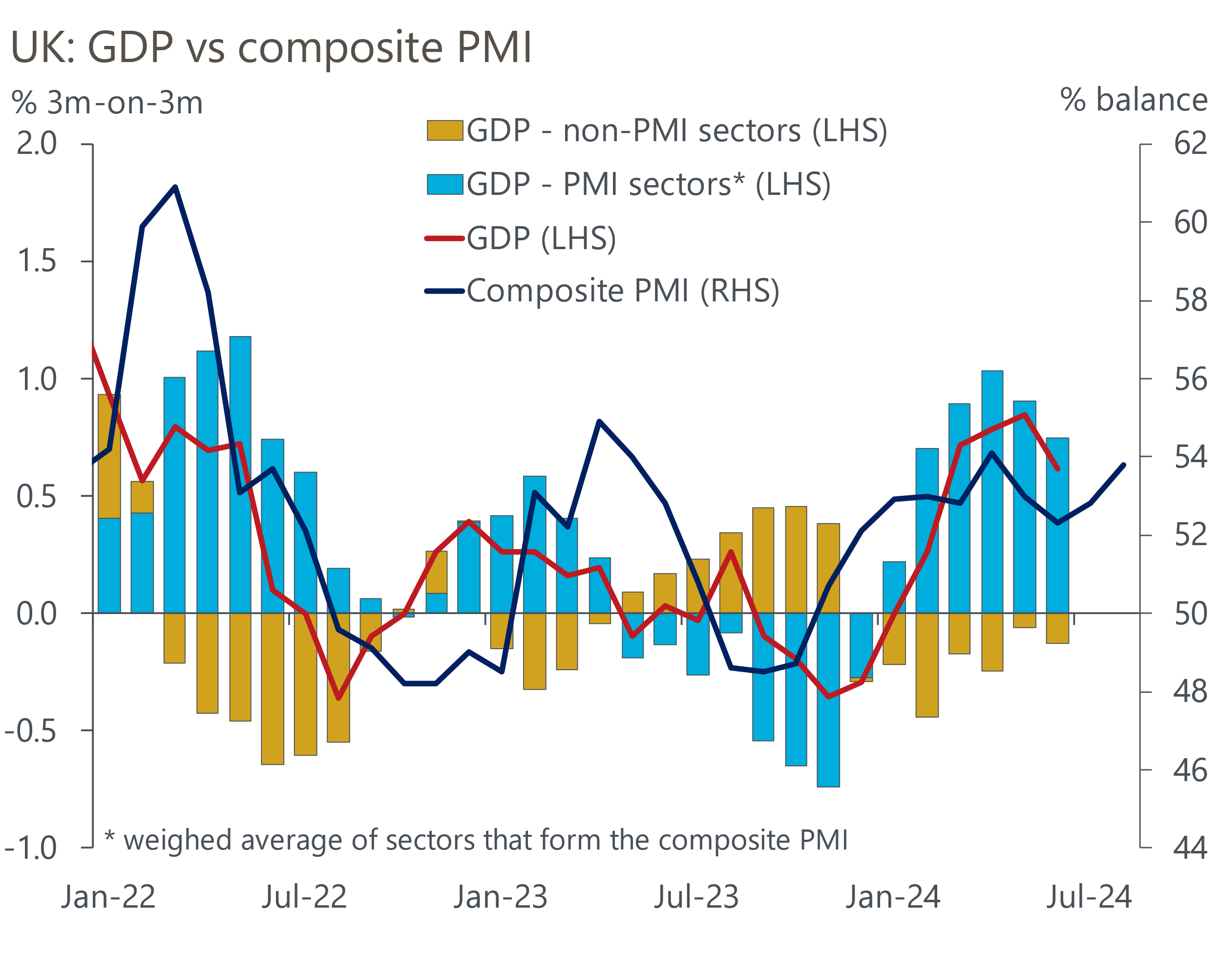
Sources: Oxford Economics, ONS, S&P Global

We published a Research Briefing this week that looked at the growth outlook for the next eighteen months in more detail. While we expect GDP growth to be softer than the H1 pace, reflecting the likelihood that fiscal policy will be tightened in the Budget on October 30 and that the lagged impact of past rate hikes will continue to dominate, we think the consensus is too low. This is because we are more optimistic that consumers will finally shed their caution and, supported by continued solid real income growth, will make a stronger contribution to GDP growth.
August's S&P Global survey also offered good news on the inflation front. Input cost inflation continued to cool across both the manufacturing and services sectors. Meanwhile, output prices rose at the slowest pace for three-and-a-half years, which suggests competitive pressures have led firms to reflect easing cost burdens in price-setting, rather than rebuilding margins.
In a similar vein, the BoE's Decision Maker Panel for August reported further softening in the backward- and forward-looking results for firms' prices and wages (Chart 2). But the responses are still much higher than would be consistent with achieving the inflation target on a sustained basis, and progress remains slow.
Chart 2: Firms' own price and wage expectations continued to cool in August
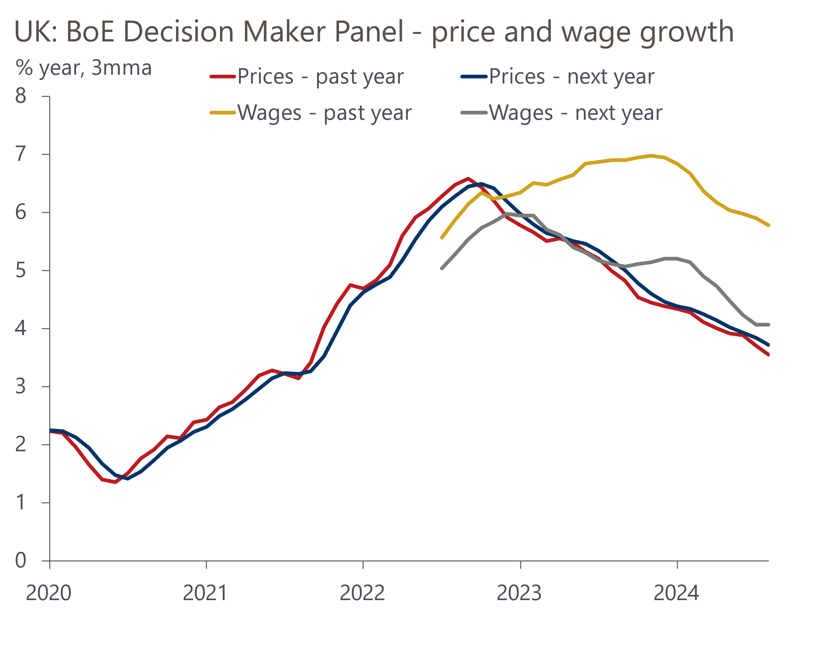
Source: Bank of England Decision Maker Panel
In the minutes of the August meeting and accompanying press conference, the MPC was at pains to emphasise it will pursue a gradual approach to loosening policy. The message was particularly aimed at dampening down expectations of another rate cut at the meeting later this month, and the gentle softening in cost and price pressures flagged by the S&P Global survey and DMP is unlikely to alter this. So it would be a major surprise if the MPC announced another cut on September 19.
Further out, we see the MPC continuing to respond to signs that pay and services inflation are slowing with further rate cuts. Our forecast assumes the MPC will cut by 25bps at every other meeting. Market pricing implies an extra cut in H1 2025 but that Bank Rate will end next year at around 3.75%, in line with our forecast. However, as we set out in a Research Briefing this week, we think it's worth considering a scenario in which the MPC returns interest rates to a neutral level more quickly due to fiscal policy being tightened more and because the impact of rate cuts on the economy is smaller and slower than in previous cycles.
The start of the rate cutting cycle has underpinned a gradual pickup in mortgage activity and house prices, with Halifax reporting a second successive monthly increase in prices. Falling swap rates led to further falls in quoted mortgage rates in August, with the average interest rate on two- and five-year fixed rate 75% LTV deals falling by 19bps and 16bps respectively. Our baseline forecast is consistent with mortgage rates drifting slightly lower over the next year, supporting a slow recovery in housing transactions and prices. If the MPC cuts more aggressively, in line with the scenario outlined above, the fall in mortgage rates would likely be larger. But borrowers refinancing five-year fixed rate mortgages would still see their debt servicing costs increase substantially.

The week ahead
The first of the week's two major economic releases is the labour market data for May-July. Whole economy total pay growth fell markedly in the three months to June, helped in large part by strong base effects from one-off bonuses paid to public sector employees last June. But base effects were also a big factor behind the more modest slowdown in regular pay growth. These base effects will continue to weigh on pay growth in the near-term, so we think headline total pay growth cooled to 4.1% in July, with regular pay growth at 5.1%.
On the quantities side, last month's Labour Force Survey showed a surprise fall in unemployment to 4.2% in the three months to June. This was driven by an exceptionally low single-month reading for June. Based on the available monthly data, we suspect the unemployment rate remained at 4.2% in the three months to July. But with the Office for National Statistics yet to introduce key methodological changes, we continue to see the LFS data as an unreliable indicator of conditions in the jobs market.
The week will also see the release of GDP data for July. Though output was flat in June, this was largely due to temporary factors which should unwind. Following a slump in June, retail sales rebounded in July, suggesting that distribution output will have recovered. Moreover, health output should have strengthened in July, after four days of strikes by junior doctors had dragged on activity in June. But we expect to see some payback in the manufacturing and business services sectors, after very strong outturns in recent months. So on balance, we estimate that GDP rose by 0.1% m/m in July.
Table 1: Week ahead calendar
Date | Events | Period | Measure | Unit | Previous | Forecast
Sep 10 | LFS unemployment | May-Jul | Rate | % | 4.2 | 4.2
Sep 10 | Average earnings (total pay) | Jul | 3m, y/y | % | 4.5 | 4.1
Sep 10 | Average earnings (regular pay) | Jul | 3m, y/y | % | 5.4 | 5.1
Sep 11 | GDP | Jul | m/m | % | 0.0 | 0.1
Sep 11 | GDP | Jul | 3m/3m | % | 0.6 | 0.6
Sep 11 | Index of services | Jul | m/m | % | -0.1 | 0.2
Sep 11 | Index of services | Jul | 3m/3m | % | 0.8 | 0.6
Sep 11 | Manufacturing output | Jul | m/m | % | 1.1 | -0.5
Sep 11 | Manufacturing output | Jul | y/y | % | -1.5 | -0.8
Sep 11 | Industrial production | Jul | m/m | % | 0.8 | -0.4
Sep 11 | Industrial production | Jul | y/y | % | -1.4 | -0.7
Sep 11 | Construction output | Jul | m/m | % | 0.5 | 0.0
Sep 11 | Construction output | Jul | y/y | % | -1.7 | -1.1
Sep 11 | UK trade | Jul | Trade balance | £bn | -7.5 | -6.8
Sep 11 | UK trade | Jul | Visible balance | £bn | -18.9 | -18.2
Source: Oxford Economics

Key forecasts
Table 2: UK forecast overview
(Annual percentage changes unless specified)
 | 2022 | 2023 | 2024 | 2025 | 2026 | 2027
GDP | 4.3 | 0.1 | 1.1 | 1.7 | 1.8 | 1.7
Private consumption | 4.8 | 0.2 | 0.6 | 2.1 | 2.0 | 1.6
Fixed investment | 8.0 | 2.2 | 0.3 | 0.9 | 2.5 | 2.1
Government consumption | 2.3 | 0.5 | 2.7 | 2.8 | 1.6 | 1.5
Exports of goods and services | 9.0 | -0.5 | -0.8 | 2.1 | 2.0 | 1.7
Imports of goods and services | 14.6 | -1.5 | 0.7 | 2.8 | 2.7 | 1.9
Industrial Production | -3.5 | -0.4 | 0.0 | 0.9 | 1.4 | 1.1
Consumer prices | 9.1 | 7.3 | 2.6 | 2.6 | 2.2 | 2.1
Unemployment rate (%) | 3.9 | 4.0 | 4.3 | 4.3 | 4.1 | 3.9
Current a/c balance (% of GDP) | -3.1 | -3.3 | -3.5 | -3.3 | -3.4 | -3.3
Government balance (% of GDP) | 4.4 | 5.0 | 4.0 | 3.2 | 2.5 | 1.7
Cen. bank policy rate (%, EOP) | 3.50 | 5.25 | 4.75 | 3.75 | 2.75 | 2.00
10yr govt. bond yield (%, EOP) | 3.67 | 3.54 | 3.94 | 3.68 | 3.23 | 2.85
Exchange rate (US$ per £, EOP) | 1.20 | 1.27 | 1.29 | 1.30 | 1.31 | 1.33
Exchange rate (euro per £, EOP) | 1.13 | 1.15 | 1.19 | 1.19 | 1.18 | 1.17
Source: Oxford Economics
Table 3: Quarterly forecasts for the UK
 | 2024 |  |  |  | 2025
 | Q1 | Q2 | Q3 | Q4 | Q1 | Q2 | Q3 | Q4
GDP (% year) | 0.3 | 0.9 | 1.4 | 2.1 | 1.8 | 1.6 | 1.7 | 1.7
CPI inflation (% year) | 3.5 | 2.1 | 2.1 | 2.5 | 2.7 | 2.5 | 2.7 | 2.5
Bank Rate (%, EOP) | 5.25 | 5.25 | 5.00 | 4.75 | 4.50 | 4.25 | 4.00 | 3.75
10yr gilt yield (%, EOP) | 3.95 | 4.17 | 3.95 | 3.94 | 3.88 | 3.81 | 3.74 | 3.68
US$ per £ (EOP) | 1.26 | 1.26 | 1.30 | 1.29 | 1.29 | 1.29 | 1.30 | 1.30
Euro per £ (EOP) | 1.17 | 1.18 | 1.19 | 1.19 | 1.19 | 1.19 | 1.19 | 1.19
Source: Oxford Economics

Latest Country Economic Forecast:
August 21, 2024

Recent publications

Data Insights
Stronger services PMI suggests GDP growth will remain solid
Stronger domestic market drove up August's manufacturing PMI
Rate cuts should drive a gradual recovery in mortgage demand
Flash PMIs suggest economic growth will remain solid in Q3
Public finances continue to disappoint ahead of Budget reset

Research Briefings
MPC easing - how far and how fast?
Growth may slow, but the consensus looks too weak
Rate-cut cycle kicks off but it’s unlikely to be sequential
Reeves review lays the ground for October tax rises
MPC preview – Markets hold the key to timing of rate cut

Contacts

Oxford Economics' UK team
- Andrew Goodwin - Chief UK Economist - agoodwin@oxfordeconomics.com
- Edward Allenby - UK Economist - eallenby@oxfordeconomics.com

